LA BARCOLANA REGATTA 2023
From 08-10-2021 to 10-10-2023

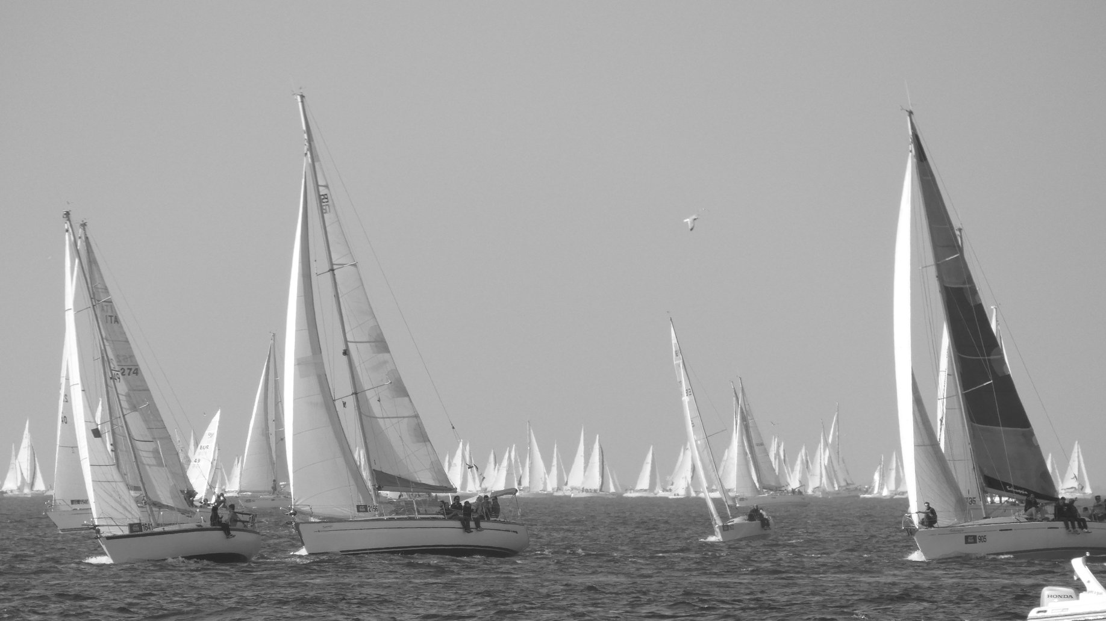

The Barcolana is the largest and most unique regatta in the world. Boats of different classes, amateurs and professionals compete along the coast in a path that ends in the stretch of sea in front of the beautiful Piazza Unità d'Italia.
The regatta takes place every year on the second Sunday of October and has reached its 53rd edition.
The city is transformed and becomes a great party for everyone. Food and wine kiosks and musical and cultural events are scheduled every year during the week preceding it.
Needless to say, this is an unmissable event not only for passionate sailors but for anyone who wants to spend a pleasant weekend in one of the most eastern cities in Italy.
Password: "good wind!"

PROGRAM
1° DAY – FRIDAY 08-10-2023
________________________________________________________________________________________
Private transfer service from the airport / arrival station to the hotel provided and accommodation in reserved rooms and free time to stroll along the streets of the center reaching the Rive and the Barcolana Village. It is an area between Molo Audace and Molo Bersaglieri, a single large container of culture, taste, entertainment and seafaring spirit with shops, restaurant, gift shop and info point.
At the end of the walk, three-course dinner at a restaurant in the center, return to the hotel and overnight.
* Private transfer service to the city (flexible pick-up time depending on your needs / only with hotel & Spa Riviera and Maximilian's option)

2° DAY – SATURDAY 09-10-2023
________________________________________________________________________________________
Breakfast. Morning dedicated to visiting the Miramare Castle and its beautiful park *. Located near Trieste, the Castle is a residence commissioned by Archduke Ferdinand Maximilian of Habsburg to live there with his wife, Princess Charlotte of Belgium. Built between 1856 and 1860, it is a unique testimony of a luxurious noble residence with its original interior furnishings. The Castle was designed in symbiosis with a luxuriant park that surrounds it. The garden, rich in precious botanical species, is a complex natural and artificial combination; along the paths there are multicolored flower beds, sculptures, monumental trees, fountains and ponds. The complex enjoys an enchanting panoramic position: it is located sheer above the sea, on the tip of the promontory of Grignano
Lunch at a seaside restaurant in the bay of Grignano below the Castle and the rest of the day available for visits to the city.
* The park can be reached with a pleasant walk from the Riviera & Maximilian's hotel (about 15 minutes)
Free dinner and return to the hotel.

3° DAY – SUNDAY 10-10-2023
________________________________________________________________________________________
Breakfast. Day of the "Barcolana".
From the panoramic terrace of the hotel after breakfast you can admire the regatta from above or from the underlying park of the Miramare Castle (Riviera & Maximilian's hotel option)
Possibility to book lunch at the property, private transfer to the airport / train station and end of services.
For guests staying at the NH hotel in Trieste, the regatta will be visible from the Rive just a few minutes' walk from the hotel. Free time available.
Private transfer to the airport / train station and end of services.

PRICE
starting from € 385 with overnight stay option at the NH **** hotel
starting from 545 € with overnight stay option at the Riviera & Maximilian's **** hotel & Spa

The price includes:

n. 1 3-course dinner, drinks not included
1 3-course lunch, drinks not included
n. 2 nights in a 4-star hotel with breakfast
n. 1 entrance to the Miramare Castle
n. 2 private transfer service as per program (3 with overnight stay at the Riviera & Maximilian's **** hotel & Spa)
Medical insurance
our Covid-19 insurance and our assistance

The Price does NOT include:
Cancellation insurance
extras and anything not specified under "The price includes"

